Zoo animals
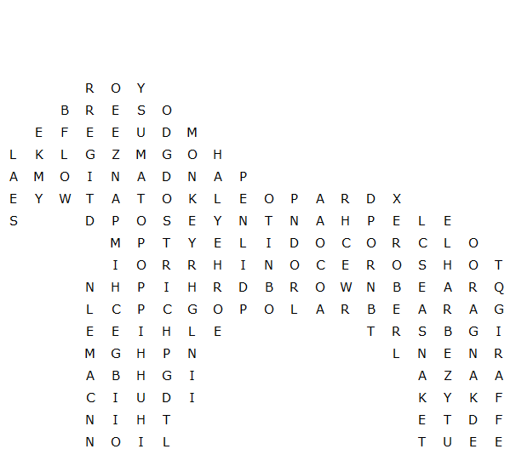

hippopotamus rhinoceros chimpanzee crocodile
brown bear polar bear kangaroo elephant giraffe
leopard penguin dolphin ostrich monkey tiger
camel zebra snake panda lion seal wolf

Zoo animals – solution

